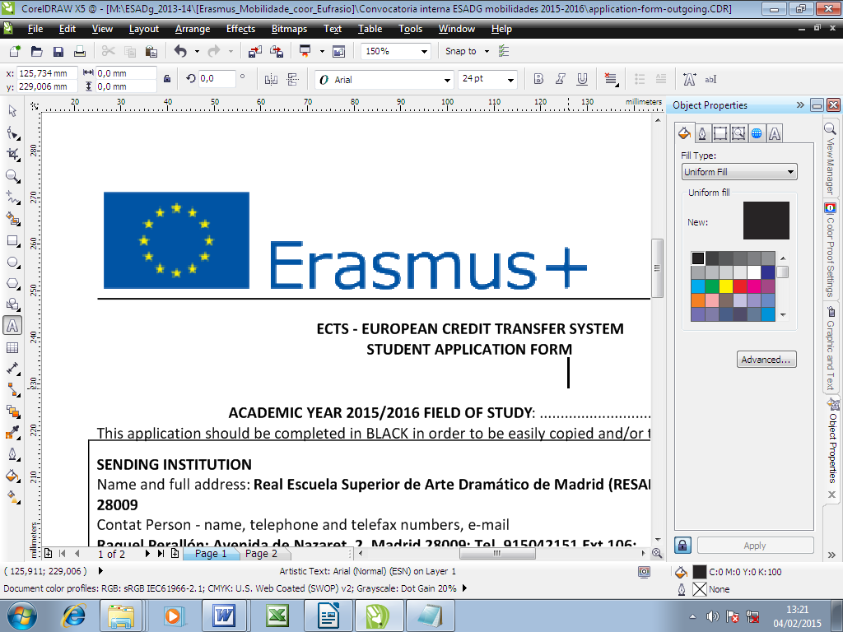 | STUDENTS APPLICATION FORM

ACADEMIC YEAR FOR THE MOBILITY: 2024/2025

FIELD OF STUDY:
❑ Acting ❑ Stage Direction ❑ Dramaturgy ❑ Set Design

TYPE OF ERASMUS + MOBILITY:
Mobility for Students | ❑ Student Mobility for Studies (SMS)
This application should be:
- completed in your computer.
- sent to internacional@esadsevilla.es before deadline.

HOME /SENDING INSTITUTION
Escuela Superior de Arte Dramático de Sevilla (ESAD-Sevilla) – Erasmus code: ES SEVILLA06
Erasmus Coordinator | Cecilia Geijo
Telephone(s) | +34 954 91 59 74 | Fax | +34 954 91 59 74
E-mail address | internacional@esadsevilla.es
Post address | Pascual de Gayangos, 33 – 41002 Sevilla

PERSONAL DATA
PERSONAL INFORMATION
Name(s)
Surname
Place and date of birth |  | ID, DNI or Passport number
Sex | ◻ Male ❑ Female
Nationality
Home address
(including postcode, town, country)
Term-Time address
(if different)
Home telephone
Mobile
E-mail address | @esadsevilla.es

PLACEMENT APPLICATION

PLACEMENT APPLICATION
Order | Institution name | Country | Period |  | Duration of mobility (months)
 |  |  | From | To
1.
2.
3.
4.
5.
…

LANGUAGE SKILLS

LANGUAGE
Spanish | ❑Mother tonge | ❑ Fluent | ❑ Good | ❑ Moderate | ❑ Limited
English | ❑ Mother tonge | ❑ Fluent | ❑ Good | ❑Moderate | ❑ Limited
Portuguese | ❑ Mother tonge | ❑ Fluent | ❑ Good | ❑ Moderate | ❑ Limited
French | ❑ Mother tonge | ❑ Fluent | ❑ Good | ❑ Moderate | ❑ Limited
German | ❑ Mother tonge | ❑ Fluent | ❑ Good | ❑ Moderate | ❑ Limited
Italian | ❑ Mother tonge | ❑ Fluent | ❑ Good | ❑ Moderate | ❑ Limited
Czech | ❑ Mother tonge | ❑ Fluent | ❑ Good | ❑ Moderate | ❑ Limited
Polish | ❑ Mother tonge | ❑ Fluent | ❑ Good | ❑ Moderate | ❑ Limited
Other: | ❑ Mother tonge | ❑ Fluent | ❑ Good | ❑ Moderate | ❑ Limited

WORK EXPERIENCE RELATED TO CURRENT STUDY (if relevant)

WORK EXPERIENCE
From (date) | To (date) | Employer, position at the company/short job description

OTHER INFORMATION

EXTRA CURRICULAR ACTIVITIES, INTERESTS
ADDITIONAL INFORMATION IN SUPPORT TO THE APPLICATION

HEALTH DECLARATION
Do you have a disability for which special arrangements may be needed to be considered for purposes of work? | Yes ◻ No ❑

EMERGENCY CONTACT
PERSON (relatives, family, close friend) TO BE NOTIFIED IN CASE OF EMERGENCY:
Name, surname
Home address
Telephone(s)

PREVIOUS MOBILITIES

Have you already been beneficiary of Eramus + programme ? Yes ❑ No ❑
How many times did you receive Erasmus + grant?
If yes, when? At which institution?

PREVIOUS AND CURRENT STUDY

Diploma/degree for which you are currently studying: Performing arts in ESAD
Number of higher education study years completed prior to departure abroad:
Have you already been studying abroad ? Yes No
If yes, when? at which institution ?
The attached Transcript of records includes full details of previous and current higher education study. Details not known at the time of application will be provided at a later stage.

Applicant’s name and signature

Date:

